**4. Create a web page using HTML/CSS which contains cards (shown as a stack of cards) with image of a tourist place and below that is a thumbnail (shown in circle with image). When mouse hovers over thumbnail, corresponding card comes in front and also small description about the tourist place will be displayed. Use ONLY CSS animation and transition. (Java script should not be used to animate.)**

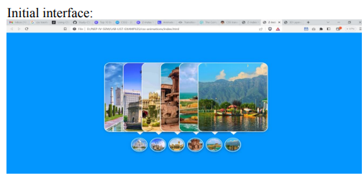

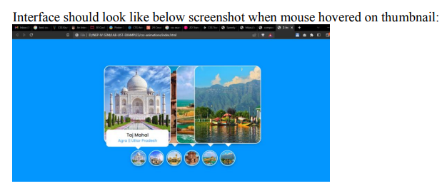

**Index.html:**

<!DOCTYPE html>

<html lang="en" dir="ltr">

<head>

<meta charset="UTF-8">

<title>Z-Index Hover Animation | CodingLab</title>

<link rel="stylesheet" href="style.css">

</head>

<body>

<div class="container">

<div class="icon-image">

<div class="icon">

<img src="C:\Users\HP\Pictures\agra.jpg" alt="">

</div>

<div class="hover-image one">

<div class="img">

<img src="C:\Users\HP\Pictures\agra.jpg" alt="">

</div>

<div class="content">

<div class="details">

<div class="name">Taj Mahal</div>

<div class="job">Agra || Uttar Pradesh</div>

</div>

</div>

</div>

</div>

<div class="icon-image">

<div class="icon">

<img src="C:\Users\HP\Pictures\goi.jpg" alt="">

</div>

<div class="hover-image one">

<div class="img">

<img src="C:\Users\HP\Pictures\goi.jpg" alt="">

</div>

<div class="content">

<div class="details">

<div class="name">Gate Way of india</div>

<div class="job">Mumbai || Maharastra</div>

</div>

</div>

</div>

</div>

<div class="icon-image">

<div class="icon">

<img src="C:\Users\HP\Pictures\bangalorefort.jpg" alt="">

</div>

<div class="hover-image one">

<div class="img">

<img src="C:\Users\HP\Pictures\bangalorefort.jpg" alt="">

</div>

<div class="content">

<div class="details">

<div class="name">Bangalore Fort</div>

<div class="job">Bangalore || Karnataka</div>

</div>

</div>

</div>

</div>

<div class="icon-image">

<div class="icon">

<img src="C:\Users\HP\Pictures\hampi.jpg" alt="">

</div>

<div class="hover-image one">

<div class="img">

<img src="C:\Users\HP\Pictures\hampi.jpg" alt="">

</div>

<div class="content">

<div class="details">

<div class="name">Hampi</div>

<div class="job">Ballari || Karnataka</div>

</div>

</div>

</div>

</div>

<div class="icon-image">

<div class="icon">

<img src="C:\Users\HP\Pictures\kk.jpg" alt="">

</div>

<div class="hover-image one">

<div class="img">

<img src="C:\Users\HP\Pictures\kk.jpg" alt="">

</div>

<div class="content">

<div class="details">

<div class="name">Kanya kumari</div>

<div class="job">Kanya Kumari || Tamilnadu</div>

</div>

</div>

</div>

</div>

<div class="icon-image">

<div class="icon">

<img src="C:\Users\HP\Pictures\dallake.jpg" alt="">

</div>

<div class="hover-image one">

<div class="img">

<img src="C:\Users\HP\Pictures\dallake.jpg" alt="">

</div>

<div class="content">

<div class="details">

<div class="name">Daal Lake</div>

<div class="job">Kashmir || Kashmir</div>

</div>

</div>

</div>

</div>

</body>

</html>

**Style.css**

@import url('http://fonts.googleapis.com/css2?family=Poppins:wght@200;300;400;500;600;700&display=swap');

* {

margin: 0;

padding: 0;

box-sizing: border-box;

font-family: 'Poppins', sans-serif;

}

body {

height: 100vh;

width: 100%;

display: flex;

justify-content: center;

align-items: center;

background: #0396ff;

}

.container {

height: 500px;

display: flex;

min-width: 400px;

align-items: flex-end;

justify-content: center;

margin-top: -55px;

}

.icon-image {

position: relative;

height: 70px;

width: 70px;

margin: 0 5px;

cursor: pointer;

box-shadow: 0 5px 10px rgba(0, 0, 0, 0.25);

border-radius: 50%;

background: #fff;

}

.icon-image .icon img {

position: absolute;

height: 95%;

width: 95%;

left: 50%;

top: 50%;

transform: translate(-50%, -50%);

object-fit: cover;

border-radius: 50%;

border: 3px solid #0396FF;

}

.icon-image::before {

content: "";

position: absolute;

width: 50px;

height: 50px;

left: 50%;

top: -50px;

transform: translateX(-50%);

}

.icon-image .hover-image {

position: absolute;

height: 350px;

width: 300px;

bottom: 100px;

left: 50%;

z-index: 0;

transform: translateX(-50%);

border-radius: 25px;

pointer-events: none;

box-shadow: 0 5px 10px rgba(0, 0, 0, 0.15);

transition: transform 0.5s ease, z-index 0s, left 0.5s ease;

transition-delay: 0s, 0.5s, 0.5s;

}

.icon-image:hover .hover-image {

left: -200px;

z-index: 12;

transform: translateX(80px);

}

.hover-image img {

position: absolute;

height: 100%;

width: 100%;

object-fit: cover;

border: 3px solid #fff;

border-radius: 25px;

}

.hover-image .content {

position: absolute;

width: 100%;

bottom: -10px;

padding: 0 10px;

}

.content::before {

content: "";

position: absolute;

height: 20px;

width: 20px;

background: #fff;

left: 50%;

bottom: -7px;

transform: rotate(45deg) translateX(-50%);

z-index: -1;

}

.content .details {

position: relative;

background: #fff;

padding: 10px;

border-radius: 12px;

text-align: center;

opacity: 0;

pointer-events: none;

transform: translateY(10px);

}

.icon-image:hover .details {

opacity: 1;

transform: translateY(4px);

pointer-events: auto;

}

.details::before {

content: "";

position: absolute;

height: 20px;

width: 20px;

background: #fff;

left: 50%;

bottom: -15px;

transform: rotate(45deg) translateX(-50%);

z-index: -1;

}

.content .details .name {

font-size: 20px;

font-weight: 500;

}

.content .details .job {

font-size: 17px;

color: #0396FF;

margin: -3px 0 5px 0;

}

.content .details a:hover {

color: #0396FF;

}

.container .last .hover-image {

transition: none;

}

.container .last:hover .hover-image {

transition: 0;

}

.last:hover .details {

transition-delay: 0s;

}